Course Description:
This United States History course consists of the following content area strands: United States History, Geography, and Humanities. The primary content emphasis for this course pertains to the study of United States history from Reconstruction to the present day (1860s – 2020s). Students will be exposed to the historical, geographic, political, economic, and sociological events which influenced the development of the United States and the resulting impact on world history.
Students are empowered to perform at higher levels as they engage in the following: analyzing historical documents and supplementary readings, working in the context of thematically categorized information, becoming proficient in note-taking, participating in Socratic seminars/discussions, emphasizing free-response and document-based writing, contrasting opposing viewpoints, solving problems, etc.

Textbooks:
- Gateway to U.S. History, Jarrett & Yang 2023
ISBN: 978-1-7353929-9-8
- America Through the Lens, National Geographic 2023
ISBN: 9781337111911

Required Materials:
Every single day, each students must be prepared with a notebook and pen/pencil. Any style notebook (composition, ring, etc.) is accepted.

Required Web applications:
Google Classroom, Remind, and Turnitin.com

Cellphone policy:
Per Florida House Bill 379:
“a student may not use a wireless communications device during instructional time, except when expressly directed by a teacher solely for educational purposes. A teacher shall designate an area for wireless communications devices during instructional time.”
Student devices will be collected at the beginning of class. Students who keep and use their phones without permission may have their devices sent to the office to be picked up by parent at the end of the day.

Plagiarism:
Plagiarism is a serious violation of the student code of conduct. Any assignment that is flagged for AI will be an automatic zero in the gradebook and beyond an initial warning, will be referred to administration for disciplinary action.

Make-up/Late Work:
Late work will not be accepted unless we have made prior arrangements. Students are responsible for communicating via email, Remind, or in person BEFORE the due date of an assignment.
If you are reaching out about missing work for the first time during the week gradebook closes for each quarter, you are too late.

Absence/Tardiness:
Students will not be allowed to make up work without an excused absence. Please note school-wide policy for what constitutes an excused absence. Unexcused tardiness will be tracked in Hero app and beyond five-minute window, will be treated as skipping class.

Failure Notice:
Each quarter, a student with a D or lower will receive a failure notice and parent/guardian will be contacted.

Grading Policy | Categories | Assignment Percentage %
- A 100 –90 | - Major Assessments/Test | - 30%
- B 89 –80 | - Minor Assessments/Quizzes | - 25%
- C 79 –70 | - Project/Presentations | - 20%
- D 69 –60 | - Classwork | - 20%
- F 59 – below | - Homework | - 5%
 | - Total | - 100%
COHEA Leadership Foundation
HONOR  - We will always  - Tell the truth  - Do the right thing  - Be team players  - Take responsibility for our actions  - Be hard working  - Be proactive, not reactive | RESPECT  - We will always Respect the rights of others to learn  - Show respect for ourselves, our school, and others  - Conduct ourselves in a courteous and appropriate manner  - Be compassionate towards all members of Bulldog Nation | LOYALTY  - We will always  - Care for others to build trust  - Help others reach their potential  - Steer clear of gossip  - Strive to be consistent and reliable  - Stay true to our words  - Be humble

Note: Syllabus is subject to change throughout the school year
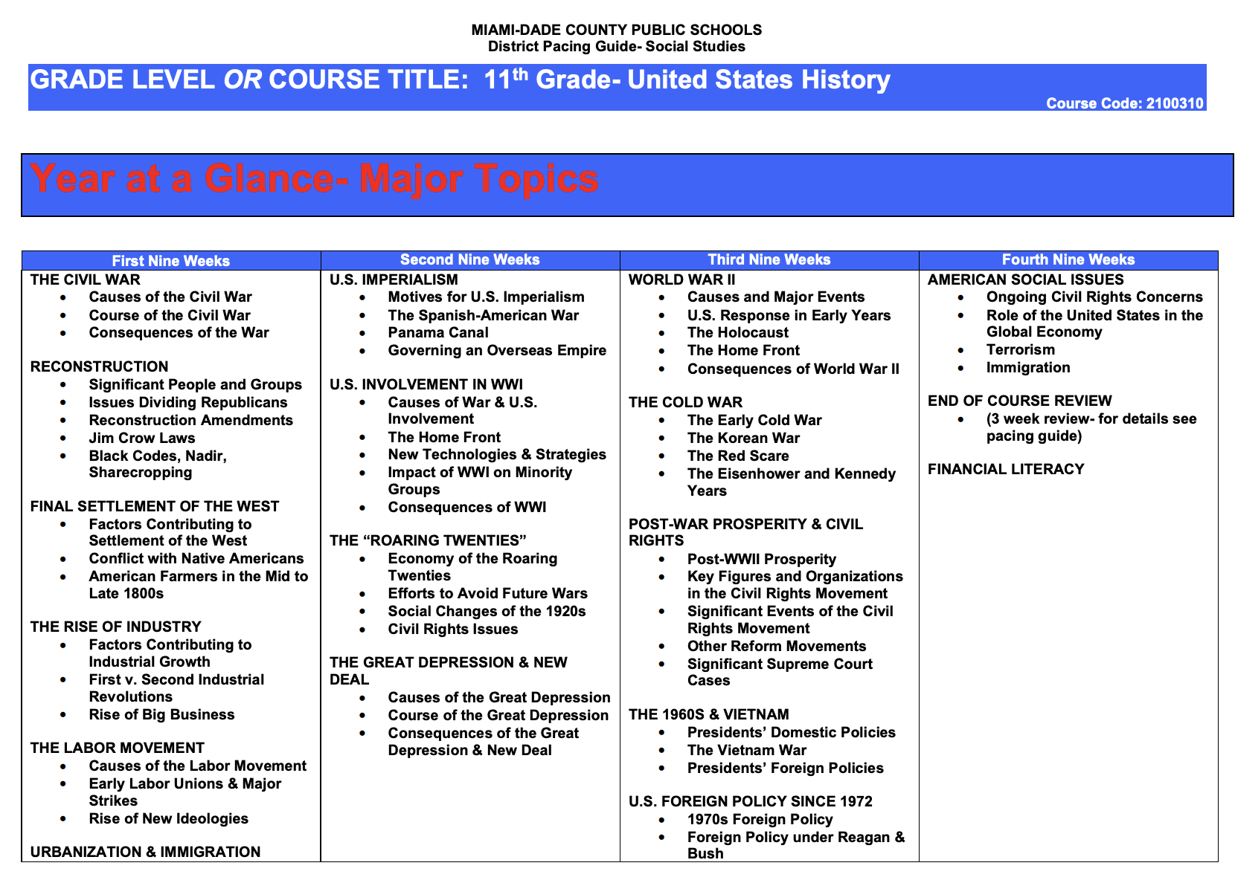
Florida U.S History End of Course Exam (EOC) Expectations:

About the Test:
- ≈ 60 Multiple Choice Questions
- The U.S. History EOC Exam is a computer-based test.
- All students enrolled in 11th grade U.S. History course must take the EOC Exam. Student performance results are used to calculate 30% of a student’s course grade. U.S. History is a graduation requirement.
- The U.S. History EOC Exam and course addresses major topics, trends, and analysis of historical importance beginning with the Civil War and ending with Modern Times.

What Skills Will You Need to Master:
- Analyze primary and secondary sources of information.
- Interpret historical trends that span across multiple time periods.
- Evaluate history from political, economic, and social perspectives.
- Understand, evaluate, and interpret graphic information (e.g., from charts).
- Understand and be able to explain the meaning of political cartoons.
- Draw conclusions from multiple pieces of complex information.
- Research and write about important historical time periods.

What Parents/Guardians can do at home to assist the student.
- Provide a quiet, organized place to study
- Talk to students about what they are learning in their history class.
- Encourage students to watch the news, read the newspaper, and ask “why or how” questions
- Discuss current events.
- Discuss political, economic and social perspectives.
- Repetition and understanding of material is the key to success.
- Open and constant communication with teacher.

